***Moonscraper* Chart Editor Design Document**

Author: Alexander “FireFox” Ong, 2016

<https://www.youtube.com/user/FireFox2000000>

*Milestones-*

* Basic chart editing with forced and tap note compatibility
* Demo/playtesting mode with GH controller compatibility
* Windows, Mac, Android and WebGL versions

*Controls-*

* Clickable scrollbar to navigate chart
* Mouse scroll: Adjust snapping, zoom, or move chart?
* Keyboard shortcuts
  + Ctrl s- Save
  + Ctrl o- Open/Load
  + Ctrl n- New

*Function list-*

System-

* New
* Open
* Save (Ctrl-s)
* Properties (name, charter, etc)
* Switch chart (difficulties etc.)

Editor-

* Default arrow (select to change individual note properties and/or delete, click and drag notes to move, right click to delete)
* Group selection
* Time display
* Snapping
* Zoom
* Offset
* Scroll bar navigation

Chart/Placeable-

* Natural, Tap
  + Left-click natural note with Natural selected to toggle forced property
  + Left-click natural note with Tap enabled to enable tap property and vice-versa
  + Default w/ sustains (Click and drag note, add horizontal for chords)
  + Staggered/bursts w/o sustains (Click and drag, vertical for strumming, add horizontal for chords)
* Star power (2 dragable sliders on the side of the chart)
* BPM
* Timescale
* Sections

Misc-

* Section cloning

*Art Asset list-*

Notes-

* Normal
* HOPO
* Tap
* SP normal
* SP HOPO
* SP tap
* Sustain

Game-

* Fretboard
* Strikeline

UI-

* Play
* Pause
* Toolpane icons
* Modepane icons

*Screen design prototypes-*

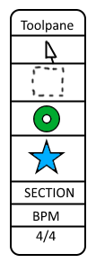Toolpane is a moveable window that allows you to select and place pieces onto the chart.

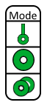The Modepane is a moveable window that determines what note type is picked when the user adds a note. Clicking on the button will cycle through the modes.

First button switches between sustains or no sustains (to make it easier to chart strumming.

The second button switches between normal notes and tap notes.

The third button switches between natural notes, strums only or HOPOs only.

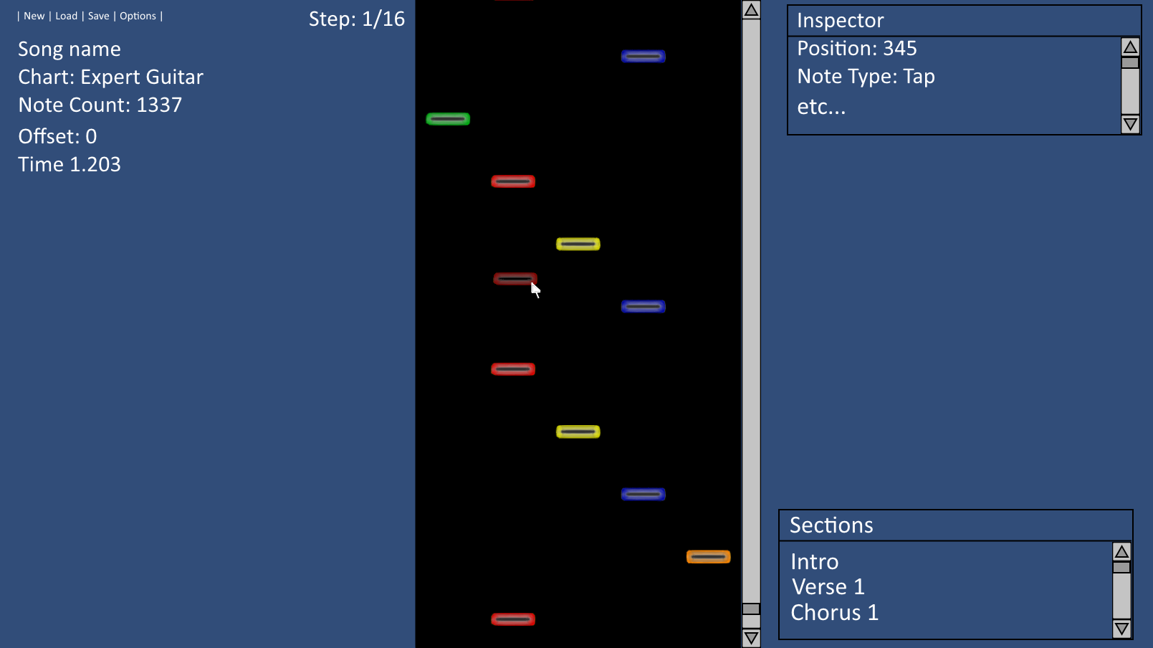

\*Preview note